Academic Researching and Referencing

using Summon
Go to: http://www.hud.ac.uk/library/
(You can also download the APA referencing guide from here and access the APA reference builders.)
Enter your search term and use the selectors underneath to restrict your search if you want to.
This is a good way of finding articles from a wide range of sources.
You can also click ‘A-Z list of journals’ to go to a specific journal, and then type in the name. When you have done this, you will be presented with a screen like this:
If you click the journal title you will see something like this:

You can search inside the journal from here.
When you have typed your search term, your results will appear as seen below:
The description text underneath appears if you move your cursor over the ‘preview’ link – this text is useful for deciding if you want to read an article before clicking on it.
You can restrict your results by using the information in the left-hand panel.
You can also browse journals through their own publisher websites.
Search for your journal on Google, e.g. “Journal of Pragmatics” and go to the relevant website.
You should be able to find a link which says ‘search articles’ or ‘search this journal’ then you can type your search term and get all the relevant articles from that journal only.
Note: all these sources can be accessed off campus, you just have to log in at http://www.hud.ac.uk/ first. You can also find your source, then copy it into Summon. Alternatively, journal sites should have an option to check access, e.g. this is from ScienceDirect:
You’re looking for ‘OpenAthens’ – depending on the site, you may have to go through a couple of checks before you get to this.
Once you’re able to click ‘OpenAthens’ the site may log you on automatically (if you’re already signed into Huddersfield university elsewhere on your browser) or you may have to search for ‘University of Huddersfield’ after clicking the ‘OpenAthens’ link. This should take you automatically to the university sign-in page, after you sign in, you should be automatically re-directed to where you were on the journal site.
Most journals can be downloaded in .pdf format and saved on your computer forever. Some however will have an expiry date, after which the file is locked. All sites including Summon will warn you if this is the case.
If you find a source you really want to read, but can’t because Huddersfield University does not have access, you have two options:
First, use Google Scholar to find the source for free: http://scholar.google.co.uk/
If it is still unavailable/pay-to-access then you can request an interlibrary loan. This is where the university locates a copy of the article or book and provides you will a physical or digital copy. This is free for most items, but the items will have strict return dates, and charges for overdue items are £2.50 per day. Often electronic sources will have an ‘expiry date’ after which you cannot access the resource any more.
Request form here: https://www.hud.ac.uk/library/borrowing/inter-library-loans/request/
More information here:
https://library2.hud.ac.uk/pages/interlibraryloans/

reading journals
Your search terms in Summon, or within a database/journal website may produce a list like this:
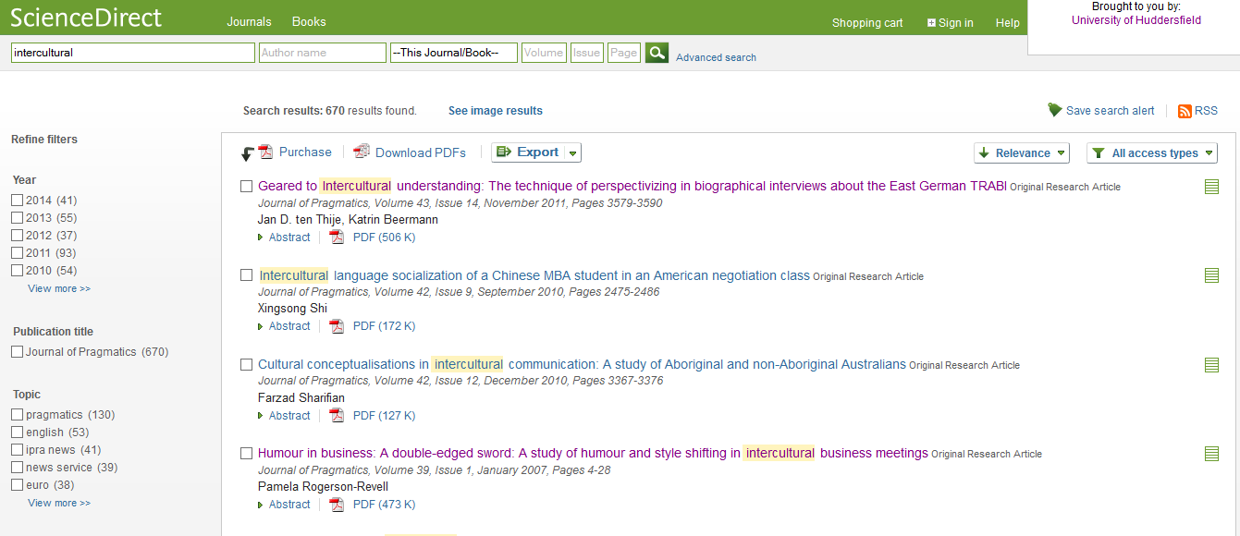
From here, just click the journal you want to read. Sometimes you can read the full text online, sometimes you have to download it.
All the information you need to reference this source.
The journal article’s abstract is a short summary which should talk about the topic of the paper, the data used and give a brief description of outcomes. It’s a good way to assess whether or not you’ll find the paper’s topic interesting and a good way to assess the author’s writing style (just because someone is an expert on something doesn’t make them a good writer, my advice would be to avoid anything that looks too difficult/boring to read – you won’t concentrate properly if this is the case and it will just be wasted time), find something you will enjoy reading and try to get the most out of it.

referencing
You need to use references when:
You directly quote something someone else has written. Direct Quotes
And, when you summarise an idea, use a technical term or explain a theme from someone else’s work. Indirect Quotes
Direct quotes need page numbers included in the reference if these are available:
(Smith, 2006, p. 74)
Online sources are unlikely to have page numbers, in this case, just use the date alone.
Indirect quotes just need the author’s name and the date of publication:
(Smith, 2006)
The referencing style above is for quotes known as in-text references, these occur when you integrate what someone else has said into your own writing:

An indirect in-text reference
In Trudgill’s 1972 study of a close-knit community in Norwich, he found that middle class men aimed for a more streetwise, ‘macho’ standard because they wanted to identify with the lower class norm (Trudgill 1972).
A direct in-text reference
As Glenn states, “People are more likely to laugh if others around them are laughing. In many… social environments, laughs beget laughs and laughter invites laughter” (Glenn 2003, p. 53)
As you can see in the example above, Glenn’s words are in quote marks to show that these are not my words.
If a quote is too long to fit within the text, then the quote should stand alone without quote marks, indented from the left-hand side:
Lule states that it is common that:
War itself is… employed as a structural metaphor in US culture. Politicians have declared war on drugs, war on poverty, and war on crime. War also permeates the language of sports, debate, and medicine.
(Lule, 2004, p. 183)
In these cases, entities and concepts are seen as the enemy, which must be defeated.
The words above and below the quote are my own. The author, date and page number should be right-aligned underneath the quote.
Where a text has multiple authors:
If there are two, always use both in your in-text reference: (Smith & Jones, 2006)
If there are 3-5, list all of them in your first reference (Smith, Jones, Thomas & McGowan, 2006) and in all subsequent references, use just the first author followed by the words ‘et al.’ (this is Latin for ‘and others’) (Smith et al., 2006)
For 6+ authors, use first author plus ‘et al’ throughout.

Bibliography
Your bibliography should only contain entries from sources you have referenced in your text (not everything relevant you’ve read – if you haven’t used it, don’t list it).
All sources are referenced slightly differently, standard books and journals are referenced as follows:
Book:
Lakoff, G. and Johnson, M. (1980) Metaphors We Live By, London: The University of Chicago Press
Journal (online):
Bray, J. (2007). The ‘dual voice’ of free indirect discourse: a reading experiment. Language and Literature, 16 (1), 37-52. doi: 10.1177/0963947007072844.
(some journal articles may not have a DOI – this is a unique identifier so the source can be found online – if there isn’t one, don’t worry, if the source can be found online, use a url instead, and if not, leave this area blank)
For all other source types, use the links below for more information.
Some useful links
University APA reference builders (just select your source, enter your information and it will output a formatted reference – but do double check these are right!)
http://www.hud.ac.uk/library/finding-info/apa-referencing/reference-builders/
APA referencing guide
https://library.hud.ac.uk/webpages/files/APA%20Full%20guide%20Sept15.pdf
or: https://owl.english.purdue.edu/owl/resource/560/03/
Grammar and Writing tips:
http://www.quickanddirtytips.com/grammar-girl
My blog:
http://lizmarsden.wordpress.com
(Caution: for my degree I used Harvard style, it’s very similar to APA, but there are a few differences in formatting. Most of my blog entries have examples using Harvard style):
How to allowably alter direct quotes to make them fit into your writing:
http://lizmarsden.wordpress.com/2012/01/16/tips-and-tricks-4-altering-quotes/

